|  |  |
| --- | --- |
| **WC Logo.emf** | **Staff Report to the County Commission**  *Weber County Planning Division* |
|  | |

****Synopsis****

****Application Information****

**Application Request:** Consideration and action on a request for final approval of Arrowhead Meadow Subdivision Phase 1. Including a request for approval of a subdivision improvement agreement for the amount of $29,612.50

**Agenda Date: Tuesday, August 11, 2020**

**Applicant: Curtis Hyde**

**File Number:** UVM122019

****Property Information****

**Approximate Address:** 9379 E 1800 S

**Project Area:** 29.50 Acres

**Zoning:** Forest Valley (FV-3)

**Existing Land Use:** Vacant

**Proposed Land Use:** Residential

**Parcel ID:** 20-037-0014

**Township, Range, Section:** T6N, R2E, Section 28

****Adjacent Land Use****

**North:** Residential **South:** Agricultural

**East:** Agricultural **West:** Residential

****Staff Information****

**Report Presenter:** Felix Lleverino

**flleverino**@co.weber.ut.us

801-399-8767

**Report Reviewer:** TA

Applicable Ordinances

* Title 101 (General Provisions) Section 7 (Definitions)
* Title 104 (Zones) Chapter 14 (Forest Valley (FV-3) Zone)
* Title 106 (Subdivisions) Chapters 1, 2, 4, 7, & 8

Development History

On April 28th, 2020, Arrowhead Meadow Subdivision Phase 1 (Formerly known as Monastery Cove Subdivision Phase 2) was granted preliminary approval by the Ogden Valley Planning Commission.

Background and Summary

The lots and short public road extension for the Arrowhead Meadow Subdivision Phase 1 will occupy an area of roughly 7.73-acres. Each lot within this development will have culinary water served by an existing private well as shown on page 6. Each lot will have a septic system.

The proposed subdivision conforms to both the zoning and subdivision requirements including adequate frontage and access along a dedicated county road, adequate lot width, lot area, as required in the Uniform Land Use Code of Weber County (LUC).

This proposal includes a request for approval of the Subdivision Improvement Agreement to create an escrow account for $29,612.50. The remaining subdivision improvements are listed in the cost estimate on page 17.

Analysis

*General Plan*: This proposal is in conformity with the Ogden Valley General Plan (OVGP) by encouraging low-density development (see page 21 of the OVGP).

*Zoning*: The property is located in the FV-3 Zone. The purpose of this zone is stated in the LUC §104-14-1.

*“The purpose of the Forest Valley Zone, FV-3 is to provide an area for residential development in a forest setting at a low density, as well as to protect as much as possible the naturalistic environment of the development.”*

*Drinking-Water Source Protection Zone*: Each operating well location with its associated 100’ radius well protection area is depicted on the plat pursuant to LUC 106-1-5 (a)(6).

*Sensitive Lands*: Weber County Sensitive Lands Map indicates the presence of a natural ephemeral stream that runs through lot 102. The dedication plat shows the stream centerline and the stream corridor setback.

*Secondary and Culinary Water*: The owner has petitioned Weber Basin Water District, and the district has approved water allotments that may be used for both irrigation and culinary purposes.

*Operational Wells*: Lot numbers 201 and 202 contain functioning wells.

*Sanitary System*: Weber-Morgan Health Department has provided feasibility letters for both lots within phase 1 that are within the range of acceptability for utilization septic system.

*Alternative Access requirements*: All design, safety, and lot standards shall be met for the private access roads, as outlined in LUC §108-7-29(1), (2), (3). This requirement applies to the road built within the access strip for lot 102.

*Review Agencies*: A complete and County-Engineering-approved set of construction drawings are filed in the Planning Office. The Engineering Department requires that the public roads and private accesses be constructed in conformity with all applicable design and safety standards. An escrow account has been created for the remaining subdivision improvements and contingency fund in the event that any improvements fail or need repair.

Weber County Fire District will require that all homes within this development install sprinkler fire suppression systems which alleviate the need to install a fire hydrant and provide a secondary ingress/egress.

The plat is showing compliance with all County Surveyor requirements.

Ogden Valley Planning Commission Recommendation

On June 2nd, 2020, Arrowhead Meadow Phase 1 was unanimously approved and forwarded to the County Commission with a positive recommendation for final approval.

Planning Division Recommendation

The Planning Division recommends final approval of the Arrowhead Meadow Subdivision Phase 1. This recommendation for approval is subject to all review agency requirements and based on the following conditions:

1. The following documents and agreements shall be recorded following the recordation of the dedication plat:
   1. Subdivision Improvement Agreement
   2. Equitable Servitude Covenant
   3. Alternative Fire Protection System Covenant
   4. Onsite Wastewater Disposal System Covenant

The following findings are the basis for staff’s subdivision approval recommendation:

1. It is shown to conforms to the Ogden Valley General Plan.
2. It is shown to comply with applicable County ordinances.
3. It is shown to comply with the Forest Valley 3 zoning code site development standards.

Exhibits

1. Arrowhead Meadow Phase 1
2. Subdivision Improvement Agreement Draft

Location map

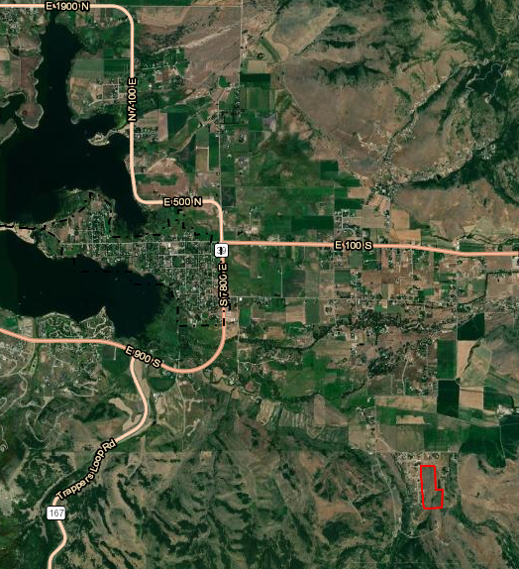

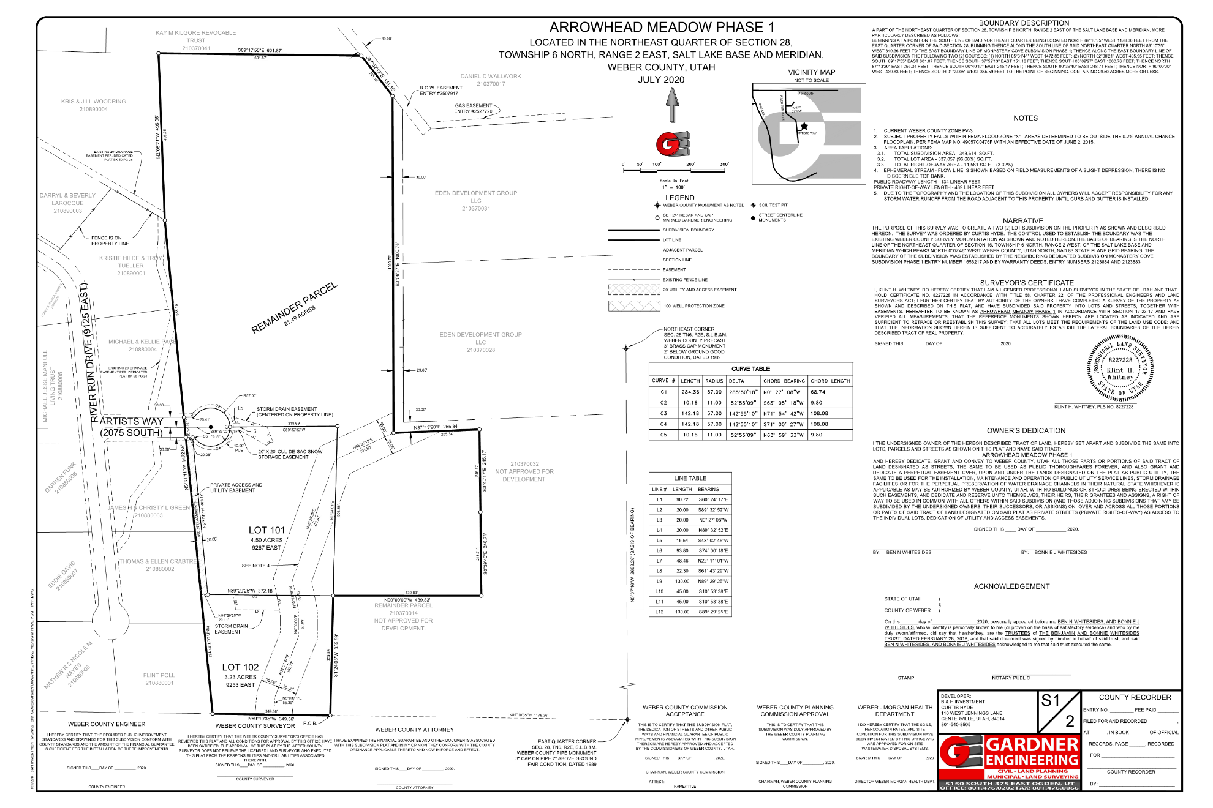Exhibit A

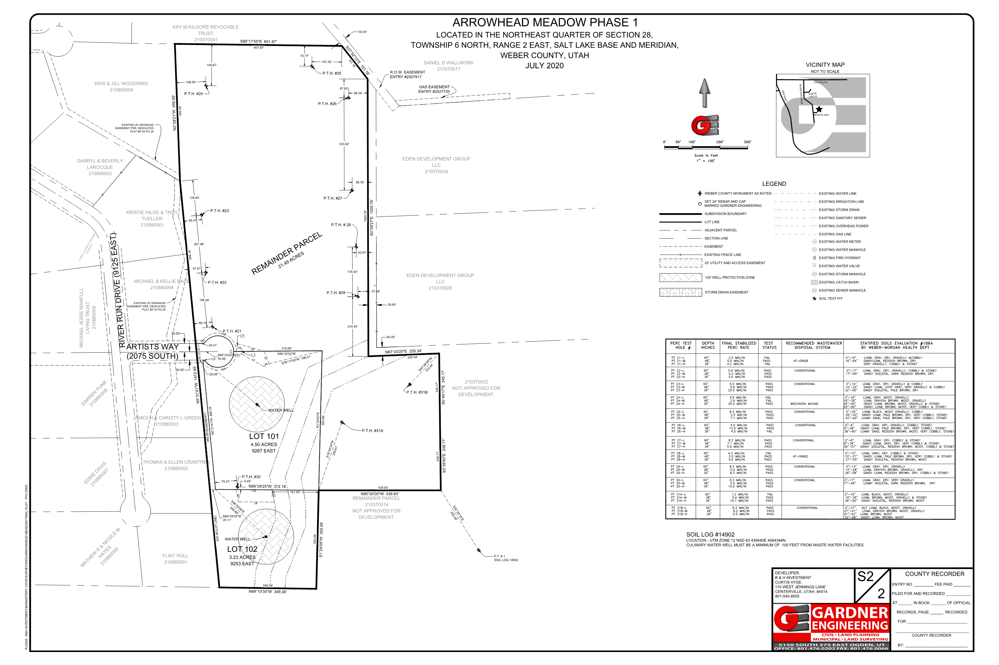

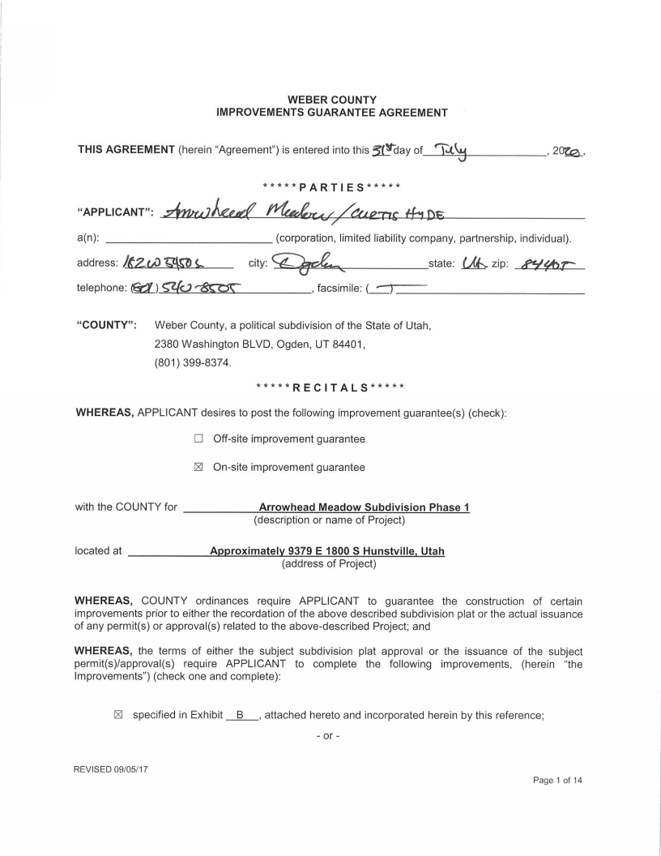Exhibit B

